Curso de Postgrado: EVOLUTIONARY PALEONTOLOGY, EVO-DEVO, AND PALEOBIOLOGY

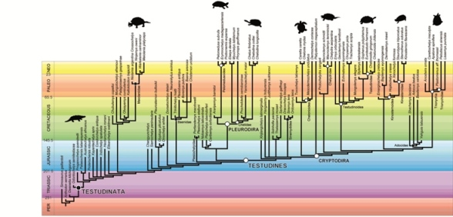

Profesor: PhD. Michel Laurin (Muséum National d’Histoire Naturelle - CNRES). http://www2.mnhn.fr/hdt203/info/laurin.php

Fecha: 7 al 11 de Octubre de 2013.
Carga Horaria: 30 hrs.
Costo de la inscripción: $500 (socios de la APA) $650 (no socios)
Cupo: 30.

Temario
1) Comparative analysis of data and paleobiological inference: the example of bone microanatomy and of lifestyle (aquatic to terrestrial): 4 h lecture; 4 h workshop. Topics: why and how the phylogeny must be incorporated into comparative analyses; character optimization through linear and squared-change parsimony; detection of a phylogentic signal; character correlation assessed through Phylogenetic Independent Contrasts (PIC), variance partition with PVR (briefly) and pairwise comparisons; comparison of the performance of the methods; evolutionary models (Brownian motion, Ornstein-Uhlenbeck, speciational) and how to test them; phylogenetic diversity index (PDI) for comparative studies; testing for equality in evolutionary rates between taxa or states; how to build, use, and distribute inference models. These will be illustrated with the example of the diversity of bone microstructure in extant tetrapods in various taxa of various lifestyles and how to model these data with Bone Profiler, and using data from the cecal appendix for tests of equality of evolutionary rates. The workshop will show how Mesquite can be used to perform several steps of the analysis (character optimization, phylogenetic signal detection, PIC, etc.); Photoshop editing of pictures and drawings for Bone Profiler; using Bone Profiler; demonstration of the use of some paleobiological inference models in Excel spreadsheets.

2) Dating the Tree of Life: how and why paleontologists should contribute: 2h lecture; 2 h workshop. Topics: Uses of timetrees in biology (conservation biology, functional biology, biogeography, nomenclature, paleobiological inferences, etc.); molecular and paleontological dating principles; the use of Stratigraphic Tools; calculation of confidence intervals on the origin of taxa; incorporation of phylogenetic uncertainty in computing ranges of minimal clade ages; total evidence dating. The workshop will allow participants to build time-calibrated trees using Mesquite and the Stratigraphic Tools and to perform branch length transformations that retain the temporal information of terminal taxa (i.e. fossils).

3) Analysis of ontogenetic timing data in comparative datasets: 2 h lecture; 2h workshop. Topics: Paleontological ontogenetic sequence data (growth series, sequences of events); use of size or developmental stage as time proxies; continuous analysis; event pairing with PARSIMOV; what the simulations show about their respective performance (ancestral condition inference, heterochrony detection, and phylogenetic signal detection); implications of cranial ossification sequence data on the origin of extant amphibians; standardization of ontogenetic data for comparative analyses; detection of heterochronies on a phylogeny; inferences of ancestral sequences; obtaining a phylogeny from ontogenetic data. The 2h workshop will allow participants to standardize data and apply the continuous analysis to infer ancestral conditions, detect heterochronies, compare with event pairing, and produce data matrices for use in phylogenetic analyses.

4) Detecting trends in comparative (paleontological) data: 1 h lecture; 1h workshop. Topics: What are evolutionary trends; why the diversity in current methods hampers comparisons; why some methods are invalid and how we determine this; methods that work; importance of the phylogeny and of temporally spread (i.e. paleontological) data. The workshop will use Mesquite with the PDAP:PDTREE module to assess the presence of evolutionary trends.

Note: Participants should bring their own data to analyze, if they have such data. However, all workshops will start using datasets provided by the instructor. Course and workshop durations are approximate; participants will be encouraged to ask questions during the talks, and discussions will be encouraged in the workshops, and they should bring their own laptop computer.

Programa completo

Para más información contáctese con la Asociación Paleontológica Argentina: secretaria@apaleontologica.org.ar

